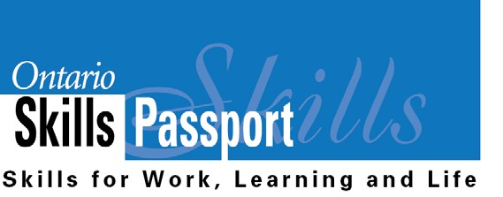
My Work Habits – Junior
– Individual Assignment

I am someone who…

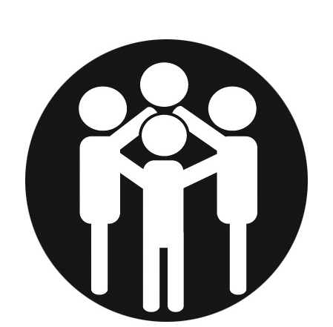
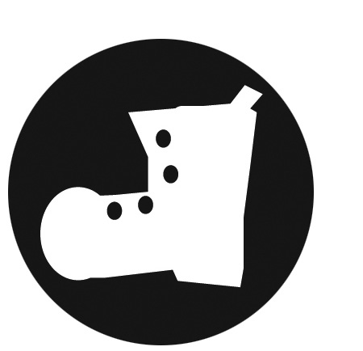
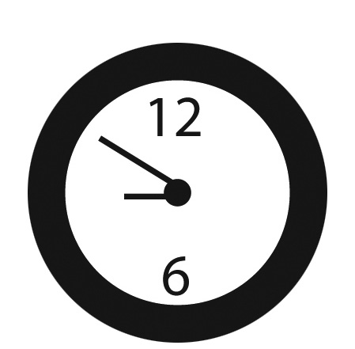

Wears a helmet when I bike,
rollerblade or snowboard.
Completes my fair share of group assignments.
Returns items I borrow on time
(e.g., library books).

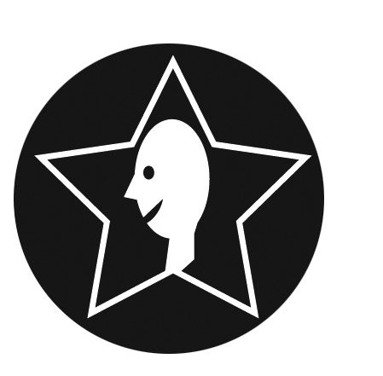
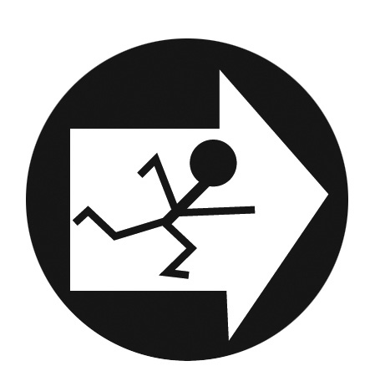

Uses my planner to know when assignments are due.

Can stand up to bullies.
Can be depended on to complete homework and assignments.

Is friendly with people, even if I’m having a bad day.
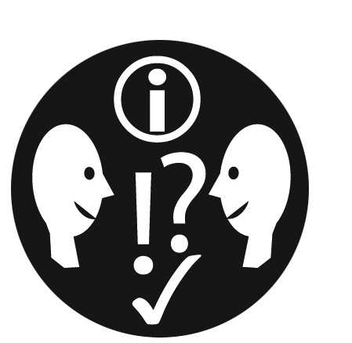
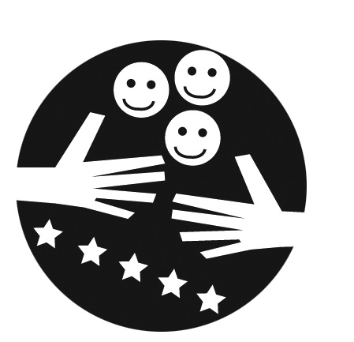
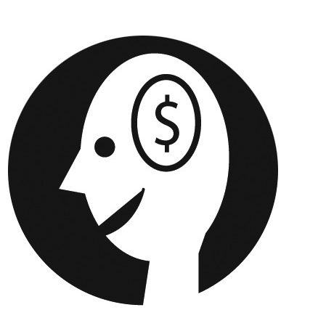
Volunteers in the school and participates in extracurricular activities.

Thinks of ideas for fundraisers for
school trips or social justice events.

